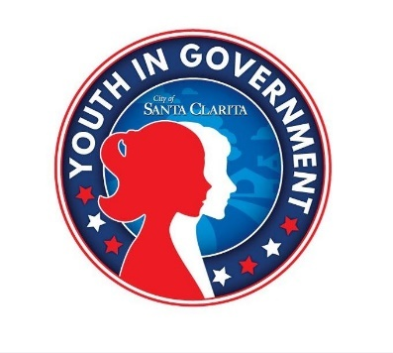**2024-2025 MEETING SCHEDULE**

|  |
| --- |
| **Thursday, September 19**  4:30 – 6:00 p.m.  City Hall – Carl Boyer Room |
| **Tuesday, October 29**  4:30 – 6:00 p.m.  *Students will also participate in a City volunteer engagement opportunity*  *during the month of October. Date to be determined.* |
| **Thursday, November 14**  4:30 – 6:00 p.m. |
| **No Meeting: December 2024** |
| **Tuesday, January 21**  4:30 – 6:00 p.m. |
| **Tuesday, February 25**  4:30 – 6:00 p.m. |
| **Tuesday, March 18**  4:30 – 6:00 p.m.  *Students will also participate in a City volunteer engagement opportunity*  *during the month of March. Date to be determined.* |
| **Tuesday, April 29**  4:30 – 6:00 p.m. |
| **Tuesday, May 13**  5:00 – 7:00 p.m. |
| ***City of Santa Clarita***  ***City Hall***  ***23920 Valencia Boulevard***  ***Santa Clarita***  ***\*The meeting details and location will be provided***  ***at the September 19 meeting.*** |

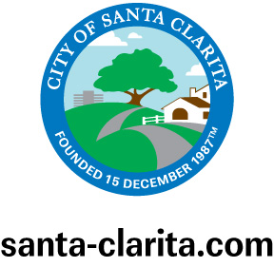

**Contact Information**

**Christian Canales**, Program Specialist

(661) 250-3749

ccanales@santa-clarita.com

**Purpose**

**The Youth in Government program aims to educate high school-aged youth about how local government works while fostering** a sense of community responsibility through volunteerism.