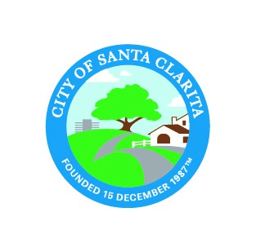 |  | Agenda Item: 11
CITY OF SANTA CLARITA
AGENDA REPORT

Consent Calendar |  |  | 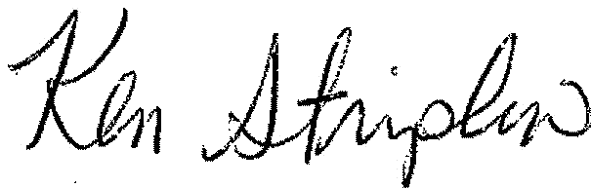
CITY MANAGER APPROVAL:
DATE: | April 28, 2020
SUBJECT: | STATE LEGISLATION: SENATE BILL 797
DEPARTMENT: | City Manager's Office
PRESENTER: | Masis Hagobian
RECOMMENDED ACTION

City Council adopt the City Council Legislative Committee recommendation to support Senate Bill 797 (Wilk) and transmit position statements to Senator Wilk, Santa Clarita’s state legislative delegation, appropriate legislative committees, Governor Newsom, and the League of California Cities.

BACKGROUND
Authored by Senator Scott Wilk (R-21-Santa Clarita), Senate Bill 797 requires that if the State Water Resources Control Board (SWRCB) has not made a final determination on an application to appropriate water within 30 years from the filing date of the application, then SWRCB would need to issue a new notice and provide an opportunity for a public hearing and protest.
Under existing law, SWRCB administers a water rights program where it grants permits and licenses to appropriate water. This administrative process allows for a protest period, and SWRCB is required to hold a hearing as long as a protest remains unresolved or there is a disputed material fact.
However, existing law does not require SWRCB to allow for additional public review on applications it has not rendered a final determination, even if decades have passed since the original filing date. This results in cases where long-standing water appropriation applications lack the most current information and withhold any opportunity for public comment, in some cases for over three decades, limiting SWRCB’s ability to fully vet an application with an understanding of the current environmental circumstances and public engagement prior to a determination.
Senate Bill 797 would apply to the proposed Soledad Canyon mining project, should the termination of the contracts not be upheld. This bill will seek to guarantee that in the event the mining project goes forward, the public is afforded a full opportunity to ensure that the SWRCB is in possession of the most current information prior to deciding whether to issue a water appropriation permit.
The original water appropriation permit application for the proposed Soledad Canyon mining project is now over a quarter-century old, having been filed in June 1991. If this bill passed, it would be effective January 1, 2021, and would apply to the proposed Soledad Canyon mining project beginning in June 2021.
This measure will not extinguish any valid rights of an applicant or limit the authority of the SWRCB to issue notices or take other actions related to consideration of an application. The bill seeks to provide a fair opportunity for interested persons to file protests or otherwise be heard by the SWRCB regarding aged applications.
In the case of the proposed Soledad Canyon mining project, significant changes have occurred in the community within the past 25 years. For example, SWRCB may wish to consider the available and dependable water supply to the community as a result of the multi-year drought. Santa Clarita’s water supply is comprised of approximately 50 percent groundwater and 50 percent imported water from the State Water Project. A review of the current role of the Santa Clara River, as it relates to habitat of the protected unarmored three-spine stickleback found in portions of the river near the proposed mining site and as a source of recharging the local aquifers, would appear appropriate when considering the permit application.
Furthermore, since 1990, Santa Clarita’s population has more than doubled from approximately 110,000 residents to the current population of approximately 225,000. As these examples demonstrate, a number of significant changes have occurred in the area over the past quarter-century. Therefore, it is appropriate for the SWRCB to fully consider present day dynamics and circumstances rather than relying on information that is significantly out-of-date in making decisions with long-term impacts.
The Santa Clarita City Council sponsored and supported a similar bill, Senate Bill 146 (Wilk) on February 14, 2017, based on the recommendation of the City Council’s Legislative Committee. Senate Bill 146 did not advance in the Senate.
Senate Bill 797 was introduced on January 6, 2020, and referred to the Senate Committee on Natural Resources and Water. The committee hearing date in the Senate Committee on Natural Resources and Water is scheduled to be held on March 24, 2020.
The City Council Legislative Committee met on March 10, 2020, and recommends that the City Council adopt a “support” position on Senate Bill 797.
ALTERNATIVE ACTION
1. Adopt a “neutral” position on Senate Bill 797
2. Adopt an “oppose” position on Senate Bill 797
3. Take no action on Senate Bill 797
4. Refer Senate Bill 797 back to the Legislative Committee
5. Other action, as determined by the City Council

FISCAL IMPACT
The resources required to implement the recommended action are contained within the City of Santa Clarita's adopted FY 2019-20 budget.

ATTACHMENTS
SB 797 - Bill Text

