City of Santa Clarita

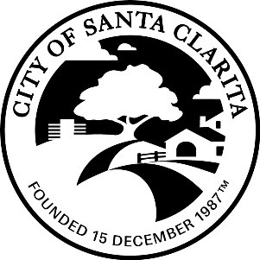
Engineering Services Division

lot areas on final maps
  - Gross Area - computed to the boundary of each lot and/or sidelines of dedicated streets
  - Net Area
Net lot areas are primarily for the benefit of the Assessor Map Section. To confirm more closely with the procedures followed by the Assessor Map Section, the following types of areas will be subtracted from the gross area of a lot to obtain the net lot area that is shown on maps processed by this office:
        - Private Streets
        - Future Streets
        - Private and Future Streets
        - Flood Hazard Areas
        - Geological Restricted Use Areas
        - Slope Easements
        - Public Riding, Hiking, and Equestrian (bridle) Trail Easements
        - Public Sidewalk Easements (If delineated on map)
        - Public Pedestrian Walkway Easements (If delineated on map)
        - Ingress an Egress Easements (If meandering through a lot or serving more than 1 lot or parcel of land)
        - Ingress and Egress Easements to be reserved in documents for the use of 3 or more lots or parcels
        - Fire Lanes
        - Flood Control District Easements
        - Private Driveways (Labeled as private driveways on the final map and serving 3 or more lots, parcels, or units.)
        - Any storm drain, or flood control easement that meanders through a lot
        - Private Driveways (If labeled like a private street with a name on the map)
        - City of Los Angeles Water & Power Department Transmission Line Easements.
        - Overhead Highway Easements
        - Overhead Power Line Easements 100’ or more in width
        - Flood Control, drainage, or storm drain easements that are adjacent to a property line and 20’ or more in width
        - Fire Road Easements (If meandering across lot.
        - Drainage Easements that are not adjacent to the property line regardless of width
        - Roadway Easements for public use
        - Maintenance District Easements

/tmp/in/input.doc

